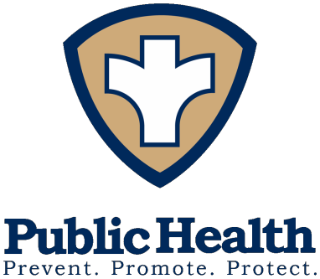
Media Release
Date: March 28, 2022 To: All Media
From: Peoria City/County Health Department
Diana Scott 309-679-6603 Tazewell County Health Department
Sara Sparkman 309-929-0264 Woodford County Health Department
Andrea Ingwersen 309-467-3064
For Immediate Release

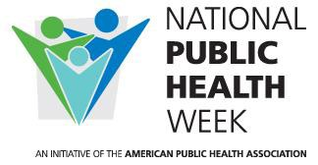

Public Health is Where You Are

Peoria, Tazewell and Woodford County Health Departments invite you to celebrate National Public Health Week April 4-10, 2022. Public Health is proud to work with members in our communities to lead initiatives that are making an impact on living a long and healthy life in a safe environment – and creating the healthiest nation for us to live, work, worship, and play.

During National Public Health Week, this year’s theme - Public Health is Where you Are – will provide a daily focus on a public health topic along with ways each person can make a difference. These topics are crucial to our success in creating the healthiest nation. Do your part to help recognize the contributions of public health and raise awareness about health and prevention!

Monday, April 4: Racism: A Public Health Crisis
Advancing racial equity involves dismantling policies and practices that uphold racism and support inequities. The COVID-19 pandemic has highlighted long-standing inequities largely driven by racism and biases resulting in a lack of access and opportunity among communities of color – inequities in health care, income, housing, education, and many other factors that influence health and well-being.

You can make a difference. Participate in a local workshop or online discussion to better understand local issues of inequities - like local food deserts, for example - and volunteer at your local food pantry.

Tuesday, April 5: Public Health Workforce: Essential to our Future
Elevating the essential health workforce is crucial to public health. Worker protections equal better health outcomes. Frontline workers deserve adequate pay, supplies and support.

You can make a difference. Here is where your vote is important. Support local efforts at building a strong and diverse public health workforce with community activities before, during, and after pandemics – such as loan repayment programs for essential workers to ensure public health readiness for our future community health.

Wednesday, April 6: Community: Collaboration and Resilience

Rebuilding communities and making them more resilient does not mean getting back to where we were before the COVID-19 pandemic – it means having the vision to create a better, more inclusive, more just world through public health. Public health infrastructure needs to be rebuilt and reinvested in.

You can make a difference. Promote policies at your worksite or with community groups to follow public health guidance – like having better food choices at vending machines and at meetings as we reopen to more social gatherings.

Thursday, April 7: World Health Day: Health is a Human Right
Strengthening community improves public health as a human right for all. Community encompasses every aspect of our lives – it’s where we live, work, learn, play, and pray. Community also plays a role in the social determinants of health, with too many people in the U.S. and worldwide facing barriers to health and well-being.

You can make a difference. Join a coalition or neighborhood group and promote projects that take action to tackle barriers to being part of the community – even actions such as promoting better sidewalks and including bike lanes are activities that make for safer neighborhoods and being a part of the community.

Friday, April 8: Accessibility: Closing the Health Equity Gap
Monitor public health data helps guide how we address issues within our most vulnerable populations by putting policies and programs in place to create a healthier nation. People living with disabilities, people living with HIV, homeless individuals, and other marginalized groups have had to combat health disparities from fewer health insurance opportunities, poor availability to appropriate healthcare, or less access to green spaces and clean air. Building more inclusive public health programs and opportunities promote healthier living for all.

You can make a difference. Work with your neighborhood group or faith community members to bring healthcare or resources to where people are – whether it is a health fair, a mobile healthcare unit, a food bank, or funds for agencies – to close a long-standing gap in health equity.

Saturday, April 9: Climate Change: Taking Action for Equity
Galvanizing climate justice means to address climate change. Climate change creates a series of interconnected impacts on human health. Building strong communities makes them more resilient. Communities with greater cohesion have better health outcomes after climate-related disasters.

You can make a difference. Our environment is important to our air, our health, our lungs. Support projects and activities that enhance our air supply – not only support Quit Smoking but tell your home complex or local restaurant that you support Tobacco-free Communities and appreciate people not smoking or vaping around you and your family.

Sunday, April 10: Mental Wellness: Redefining the Meaning of Health
Mental health is a critical component of public health. It consists of emotional, psychological and social well-being and is important from childhood through adulthood.

You can make a difference. Practice strategies like being physically active, getting at least eight hours of sleep each night, eating a well-balanced diet, practicing gratitude, participating in activities you enjoy, developing coping skills, meditating and connecting with others. All these are proven to improve mental health.

Please join us to celebrate National Public Health Week April 4-10, 2022 to build healthier communities for all.

For more information on important public health issues, visit your local health department website:
Peoria City/County Health Department www.pcchd.org Tazewell County Health department www.tazewellhealth.org Woodford County Health Department www.woodfordhealth.org

###

